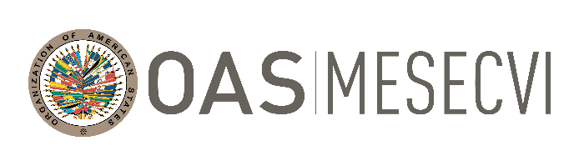

FOLLOW-UP MECHANISM OAS /Ser.L/II.7.10
BELÉM DO PARÁ CONVENTION (MESECVI) MESECVI/CEVI/263/21.corr1
Eighteenth Meeting of the Committee of Experts 27 November 2021
7 and 8 December 2021 Original: Spanish
Virtual Platform: Zoom

AGENDA

- Approval of the Draft agenda and the organization of work
- Approval of the Annual Activity Report of the Committee of Experts of the MESECVI
- Report on Child Marriage and Early Unions
- Recommendation No. 3 on the concept of consent in cases of gender-based sexual
violence
- Follow-up on the actions taken by the States Parties to the Belém do Pará
Convention to Prevent, Punish and Eradicate Violence Against Women and girls
within the framework of COVID-19 and its consideration as an emerging issue
- Presentation of the Working Group and the Strategy for the English-speaking
Caribbean Countries
- Special projects and strategic alliances of MESECVI
- Follow-up to the Fourth Multilateral Evaluation Round
- Communication strategies and new technological tools
- Election of new authorities of the Committee of Experts
- Adoption of agreements
- Other business

